Justin Sterlacci  
Internetworking  
Professor Cannistra  
March 20th, 2023

**Lab 6 Lab Report**

**Lab Description:**   
Set up a Networking using Static Router, RIPv2 Routing, and EIGRP Routing.

**Topography:**  
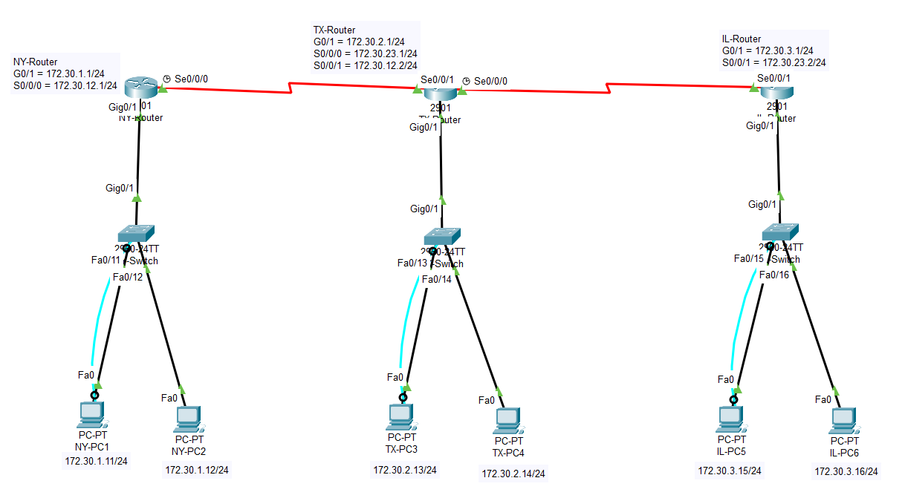  
  
Syntax:

CLI Command Description Mode of Cisco OIS

|  |  |  |
| --- | --- | --- |
| ping | Used to ping ip addresses from a PC. You can ping other PC’s or switches with this. | Windows CMD |
| Logging synchronous | Forces error messages to be on its own line, rather than interrupt a line that you’re typing on. | Console Line |
| Enable | Enter Privileged Mode | User Mode |
| Conf t | Enter Global Configurator Mode | Privileged Mode |
| Line con 0 | Enter the Console Line | Global Configurator Mode |
| Hostname | Used to name a switch or PC | Privileged Mode |
| Password | Used to set a password | Privileged Mode |
| Login | Used to require the password to utilize User Mode | Global Configurator Mode |
| Enable password | Used to set an unencrypted Privileged Password | Global Configurator Mode |
| Show ip interface brief (sh ip int brief) | Displays a brief list of all interfaces | Privileged Mode |
| vtp domain INETLAB | Renames the VTP domain from NULL to INETLAB | Global Configurator Mode |
| Vtp password cisco | Set a password within the VTP Domain | Global Configurator Mode |
| Vtp mode server/client | Sets the vtp mode between server or client, in the case of this lab. | Global Configurator Mode |
| Switchport mode access | Changes the mode of a switchport to access mode | Line configuration Mode (within a vlan) |
| Switchport trunk encapsulation dot1q | Sets up the switch to switch connect to use IEEE 802.1Q encapsulation | Within a vlan with a multi-Connection switch |
| Switchport mode trunk | Sets the mode for the switchport to trunk | Within a vlan |
| Spanning-tree vlan xx root primary | Setting up a spanning tree within a vlan, and setting it to root primary | Privileged mode |
| Encapsulation dot1q xx | Sets up a VLAN in IEEE 802.1Q within a router | ROUTER Line Configuration Mode(within a sub interface) |
| Ip route (ip) (SM) (ip) | Sets up a static IP Route | Interface Mode |
| Router rip | Sets the Router into RIP mode | Global Configuration |
| Version 2 | Sets the RIP version to version 2 | Global Configuration |
| Network (ip address) | Sets the Network for RIPv2 networking | Global Configuration |

**Verification:  
  
B)**Display G0/1 Interface:  
NY-Router  
TX-Router

IL-Router

Display WAN Interfaces:

TX-Router S0/0/1

TX-Router S0/0/0

IL-Router S0/0/1

Display Interfaces:  
NY-Router

TX-Router

IL-Router

Show Routing Table:

NY-Router

TX-Router

IL-Router

D)

NY-PC1 to TX-PC3 and IL-PC5

E)  
Texas Routers Routing table:

J)

NY-Router Routing Protocols

TX-Router Routing Protocols

IL-Router Routing Protocols

K)

TX-Router Routing Table

O)

NY-Router Routing Protocol

TX-Router Routing Protocol

IL-Router Routing Protocol

A decent amount has changed between the two, in which the most apparent one is that there is now a section for EIGRP, as well as the routing protocol for RIP. There is now also an Automatic Summarization section, which in this case is disabled.

P)

TX-Router Routing Table

**Conclusion:**This lab, while taking a lot of time to complete compared to the other labs, it was not an extremely difficult lab. The main issue I had with the lab was understanding dynamic routing as I was not in the class in which it was taught due to being in Atlantic City for the MAAC Basketball tournament. With the help of the Networking Lab, specifically the worker Fred (as he was the only one there at that time). After he assisted me in learning how to use RIPv2 and EIGRP, it was easier than first expected.